`1

Pages 2-8 – Wheel bolts
2 - 4 - Taper, radius and short headed
5 - Tuner (internal drive)
6 - Black finish (including tuner)
7 - Peugeot/Citroen/Toyota, VW
8 - Ghia, variable PCD
Pages 9-18 – Wheel nuts
9-10 - Bulge nuts open and closed
11 - Black
12 - Short, long and variable PCD
13 - Tuner nuts and keys
14-16 - Sleeve nuts and nut covers
17 - Original equipment
18 - Washers and collars

Pages 19 – 23 - Lock bolts and nuts
19 - Budget lock bolts silver and black
20 - Mid range lock bolts silver and black
21 - Limpet lock bolts
22 - Budget lock nuts silver and black
23 - Limpet lock nut
Pages 24 – 25 Studs
Pages 26 - 28 - Spacers
26 – 27 - Hubcentric and back hubcentric
22 - Universal
Pages 29 – 30 - Spigot Rings
Contact Information
Phone – 02476465845
Email – selectauto@btinternet.com
Website – www.selectautosupplies.com www.selectautosupplies.com

Wheel bolts
All bolts are zinc plated unless otherwise stated
60 ° TAPER SEATING BOLT RADIUS SEATING BOLT
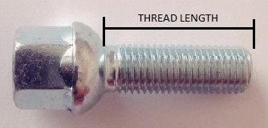
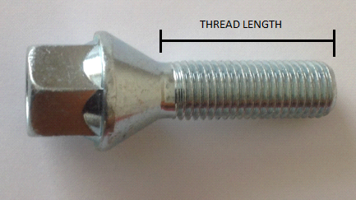
Radius seating: R12
PART NUMBER THREAD HEX SEATING LENGTH

ZB22/5T 12 x 1.5 17 taper 22mm
ZB24/5T 12 x 1.5 17 taper 24mm
ZB26/5T 12 x 1.5 17 taper 26mm
ZB28/5T 12 x 1.5 17 taper 28mm
ZB30/5T 12 x 1.5 17 taper 30mm
ZB32/5T 12 x 1.5 17 taper 32mm
ZB35/5T 12 x 1.5 17 taper 35mm
ZB40/5T 12 x 1.5 17 taper 40mm
ZB45/5T 12 x 1.5 17 taper 45mm
ZB50/5T 12 x 1.5 17 taper 50mm
ZB60/5T 12 x 1.5 17 taper 60mm

ZB26/5T19 12 x 1.5 19 taper 26mm
ZB40/5T19 12 x 1.5 19 taper 40mm

ZB23/5R 12 x 1.5 17 radius 23mm
ZB26/5R 12 x 1.5 17 radius 26mm
ZB30/5R 12 x 1.5 17 radius 30mm
ZB35/5R 12 x 1.5 17 radius 35mm
ZB40/5R 12 x 1.5 17 radius 40mm
ZB45/5R 12 x 1.5 17 radius 45mm
ZB50/5R 12 x 1.5 17 radius 50mm
ZB60/5R 12 x 1.5 17 radius 60mm

ZB40/5RL 12 x 1.5 17 radius 40mm
(6mm longer head)

PART NUMBER THREAD HEX SEATING THREAD LENGTH

ZB24/25T 12 x 1.25 19 taper 24mm
ZB26/25T 12 x 1.25 19 taper 26mm
ZB28/25T 12 x 1.25 19 taper 28mm
ZB32/25T 12 x 1.25 19 taper 32mm
ZB35/25T 12 x 1.25 19 taper 35mm
ZB40/25T 12 x 1.25 19 taper 40mm
ZB45/25T 12 x 1.25 19 taper 45mm
ZB50/25T 12 x 1.25 19 taper 50mm
ZB60/25T 12 x 1.25 19 taper 60mm

ZB24/25T17 12 x 1.25 17 taper 24mm
ZB26/25T17 12 x 1.25 17 taper 26mm
ZB35/25T17 12 x 1.25 17 taper 35mm
ZB40/25T17 12 x 1.25 17 taper 40mm
ZB50/25T17 12 x 1.25 17 taper 50mm
ZB28/75T 12 x 1.75 19 taper 28mm (Volvo)
ZB25/14T 14 x 1.5 17 taper 25mm
ZB28/14T 14 x 1.5 17 taper 28mm
ZB30/14T 14 x 1.5 17 taper 30mm
ZB33/14T 14 x 1.5 17 taper 33mm
ZB35/14T 14 x 1.5 17 taper 35mm
ZB40/14T 14 x 1.5 17 taper 40mm
ZB45/14T 14 x 1.5 17 taper 45mm
ZB50/14T 14 x 1.5 17 taper 50mm
ZB55/14T 14 x 1.5 17 taper 55mm
ZB60/14T 14 x 1.5 17 taper 60mm

ZB30/14T19 14 x 1.5 19 taper 30mm
ZB35/14T19 14 x 1.5 19 taper 35mm
ZB40/14T19 14 x 1.5 19 taper 40mm

ZB27/14R 14 x 1.5 17 radius 27mm
ZB27/14R/W 14 x 1.5 17 radius 27mm (Hollow head)
ZB30/14R 14 x 1.5 17 radius 30mm
ZB35/14R 14 x 1.5 17 radius 35mm
ZB40/14R 14 x 1.5 17 radius 40mm
ZB45/14R 14 x 1.5 17 radius 45mm
ZB50/14R 14 x 1.5 17 radius 50mm
ZB55/14R 14 x 1.5 17 radius 55mm
ZB60/14R 14 x 1.5 17 radius 60mm
ZB64/14R 14 x 1.5 17 radius 64mm

PART NUMBER THREAD HEX SEATING THREAD LENGTH

ZB34/14R19 14 x 1.5 19 radius (R14) 34mm (Nickel)
ZB60/14R/R14 14 x 1.5 17 radius (R14) 60mm

ZB27/425T 14 x 1.25 17 taper 27mm
ZB33/425T 14 x 1.25 17 taper 33mm
ZB40/425T 14 x 1.25 17 taper 40mm
ZB50/425T 14 x 1.25 17 taper 50mm
ZB55/425T 14 x 1.25 17 taper 55mm

ZB33/16T 16 x 1.5 19 taper 33mm

Short head bolts
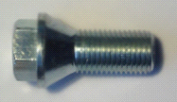
A small selection of short headed bolts to pair with bolt on spacers are available

PART NUMBER THREAD HEX SEATING LENGTH
ZB22/25T/SH 12 x 1.25 17 taper 22mm
ZB26/5T/SH 12 x 1.5 17 taper 26mm
ZB26/14T/SH 14 x 1.5 17 taper 26mm

Tuner (Internal drive) bolts
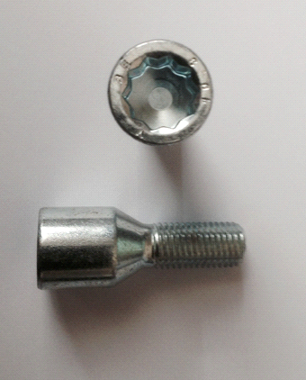

PART NUMBER THREAD SEATING LENGTH

ZB26/5TK 12 x 1.5 taper 26mm
ZB28/5TK 12 x 1.5 taper 28mm
ZB35/5TK 12 x 1.5 taper 35mm
ZB40/5TK 12 x 1.5 taper 40mm (External drive)
ZB45/5TK 12 x 1.5 taper 45mm
ZB50/5TK 12 x 1.5 taper 50mm

ZB28/25TK 12 x 1.25 taper 28mm
ZB36/25TK 12 x 1.25 taper 36mm
ZB40/25TK 12 x 1.25 taper 40mm
ZB50/25TK 12 x 1.25 taper 50mm

ZB28/14TK 14 x 1.5 taper 28mm
ZB33/14TK 14 x 1.5 taper 33mm
ZB40/14TK 14 x 1.5 taper 40mm
ZB45/14TK 14 x 1.5 taper 45mm
ZB50/14TK 14 x 1.5 taper 50mm
ZB55/14TK 14 x 1.5 taper 55mm

ZB27/425TK 14 x 1.25 taper 27mm
ZB38/425TK 14 x 1.25 taper 38mm
ZB50/425TK 14 x 1.25 taper 50mm

ZB28/75TK 12 x 1.75 taper 28mm
(External drive)

Black finish bolts
Taper Radius
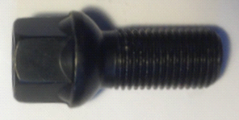
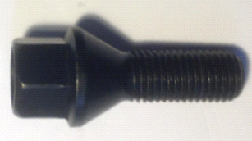

PART NUMBER THREAD HEX SEATING THREAD LENGTH
ZB26/25T17/B 12 x 1.25 17 taper 26mm
ZB26/5T/B 12 x 1.5 19 taper 26mm
ZB27/14R/B 14 x 1.5 17 radius 27mm
ZB27/14RW/B 14 x 1.5 17 radius 27mm (Loose washer)
ZB27/425T/B 14 x 1.25 17 taper 27mm
ZB28/14T/B 14 x 1.5 17 taper 28mm
ZB30/14R/POR 14 x 1.5 19 radius 30mm (PORSCHE)
ZB35/14R/POR 14 x 1.5 17 radius 35mm (PORSCHE)
ZB33/14T/B 14 x 1.5 17 taper 33mm
ZB33/425T/B 14 x 1.25 17 taper 33mm
ZB35/5T/B 12 x 1.5 17 taper 35mm
ZB35/14T/B 14 x 1.5 17 taper 35mm
ZB35/14R/POR 14 x 1.5 19 radius (R14) 34mm (Porsche)
ZB40/5T/B 12 x 1.5 17 taper 40mm
ZB40/14T/B 14 x 1.5 17 taper 40mm
ZB40/14R/B 14 x 1.5 17 radius 40mm
ZB43/425T/B 14 x 1.25 17 taper 43mm
ZB45/5T/B 12 x 1.5 17 taper 45mm
ZB45/14R/B 14 x 1.5 17 radius 45mm
ZB45/14T/B 14 x 1.5 17 taper 45mm
ZB50/14T/B 14 x 1.5 17 taper 50mm

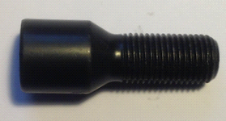
Tuner black finish bolts

PART NUMBER THREAD SEATING LENGTH
ZB26/5TK/B 12 x 1.5 taper 26mm
ZB28/14TK/B 14 x 1.5 taper 28mm

Original equipment style VW bolt
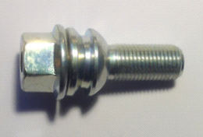

PART NUMBER THREAD HEX SEATING LENGTH
ZB30/14R19 14 x 1.5 19 radius (R14) 30mm
ZB37/14R19 14 x 1.5 19 radius (R14) 37mm
ZB45/14R19 14 x 1.5 19 radius (R14) 45mm
ZB53/14R19 14 x 1.5 19 radius (R14) 53mm

Peugeot/Citroen/Toyota bolt

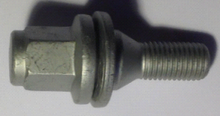
Fits:
Peugeot 107, Citroen C1,
Toyota Aygo

PART NUMBER THREAD HEX SEATING FINISH
PEB1 12 x 1.5 17 flat dacromet

Peugeot fitment bolts
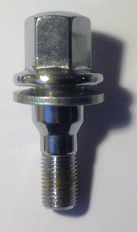
PEB2 (Up to 2000) PEB3 PEB4
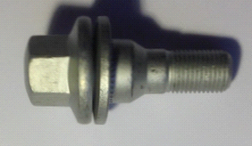
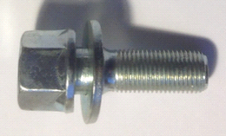

PART NUMBER THREAD HEX SEATING FINISH
PEB2 12x1.25 19 flat zinc
PEB3 12x1.25 19 flat zinc
PEB4 12x1.25 17 flat dacromet

Ghia conversion bolt

PART NUMBER THREAD HEX SEATING FINISH
10B 12 X 1.5 19 ford taper zinc
10FW (Washer – used together with 10B bolt)

Variable PCD bolts
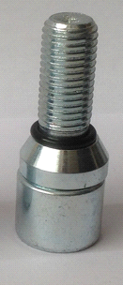
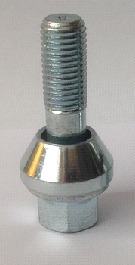

Variable PCD bolt Tuner Variable bolt
PART NUMBER THREAD HEX SEATING LENGTH

WB1 12x1.5 17 taper 32mm
WB1/40 12x1.5 17 taper 40mm
WB1L 12x1.5 17 taper 50mm
WB2 12x1.25 17 taper 32mm
WB2L 12x1.25 17 taper 50mm
WB3 14x1.5 17 taper 32mm
WB3L 14x1.5 17 taper 48mm

Tuner Variable bolt
WB1AK 12x1.5 taper 27mm
WB2AK 12x1.25 taper 27mm

Wheel nuts
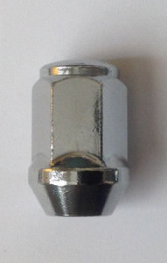
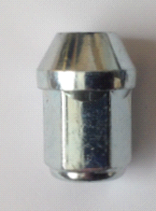
zinc nut chrome nut

Closed-end bulge nuts – Taper

PART NUMBER THREAD HEX FINISH
DN1B ½ unf 19 chrome
DN1BZ ½ unf 19 zinc
DN2B 7/16 unf 19 chrome
DN3B 12x1.25 19 chrome
DN3B/G 12x1.25 19 GOLD coloured chrome (Subaru)
DN3B17 12x1.25 17 zinc
DN3B21 12x1.25 21 zinc
DN3BZ 12x1.25 19 zinc
DN5B 3/8 unf 17 chrome
DN10B 12x1.5 19 chrome
DN10B17 12x1.5 17 zinc
DN10B21 12x1.5 21 zinc
DN10BZ 12x1.5 19 zinc
DN10LONG 12x1.5 19 chrome (50mm long)
DN14B 14x1.5 19 chrome
DN14B17 14x1.5 17 zinc
DN14B21 14x1.5 21 chrome
DN14BZ 14x1.5 19 zinc
DN14BZ21 14x1.5 21 zinc
DN15B 14x2 19 zinc
DN15B 9/16unf 19 zinc

Non- bulge type
DN20 10x1.25 19 zinc
DN321S 12x1.25 21 chrome
DN1021S 12x1.5 21 chrome
DN321 12x1.25 21 chrome
DN1021 12 x 1.5 21 chrome
DNRRZ 16x1.5 27 zinc
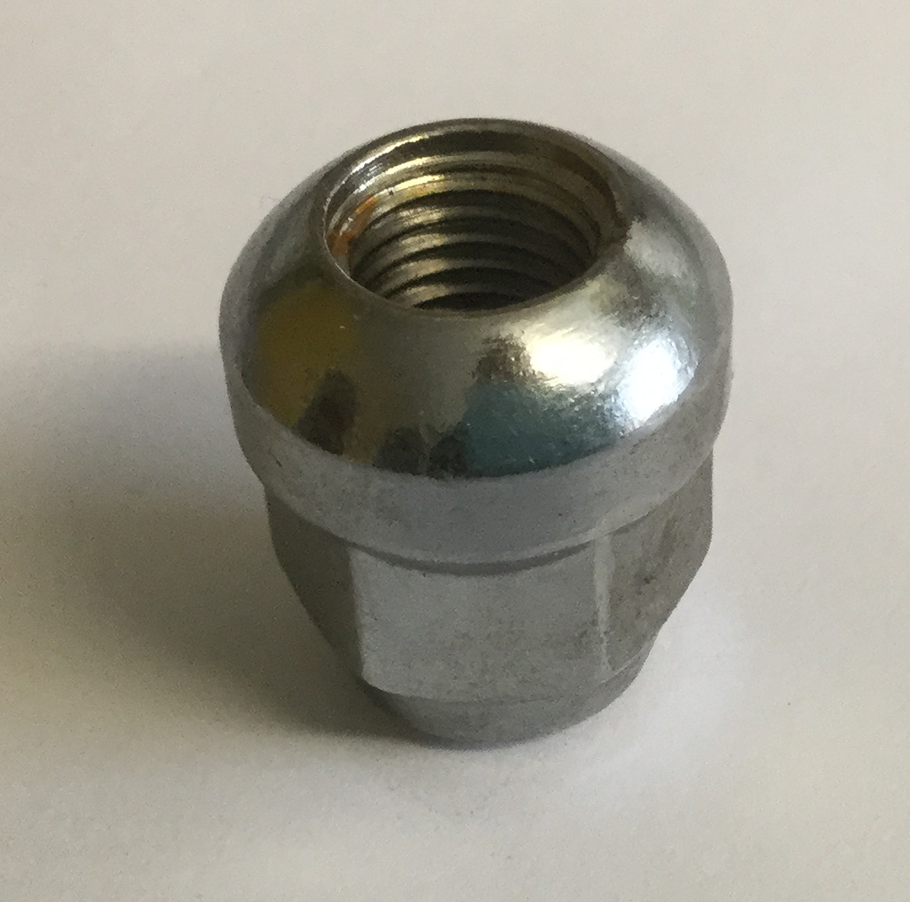
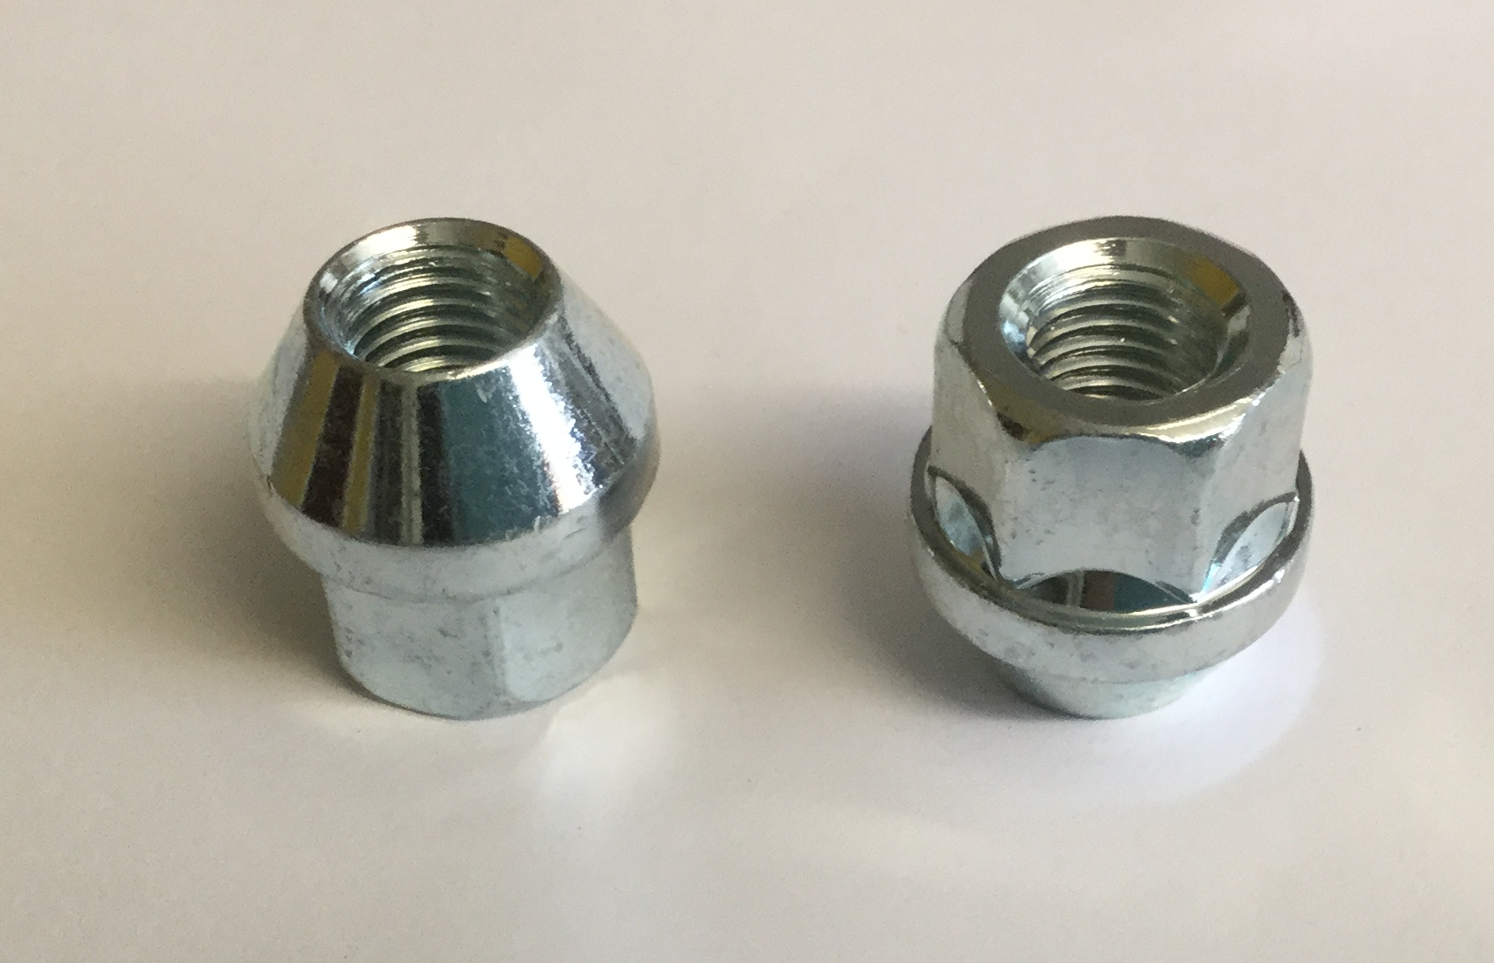

open ended nut closed radius nut
Open-end bulge nuts – Taper
PART NUMBER THREAD HEX FINISH
DN1BT ½ unf 19 zinc
DN2BT 7/16 unf 19 chrome
DN3BT 12x1.25 19 chrome
DN3BT17 12x1.25 17 zinc
DN3BT21 12x1.25 21 zinc
DN3BTZ 12x1.25 19 zinc
DN5BT 3/8 unf 17 chrome
DN10BT 12x1.5 19 chrome
DN10BT17 12x1.5 17 zinc
DN10BT21 12x1.5 21 zinc
DN10BTZ 12x1.5 19 zinc
DN14BT 14x1.5 19 zinc
DN15BT 14x2 19 zinc

Open- end non-bulge nuts

DN5OEND 3/8unf 17 zinc (taper)
DN6OEND 3/8unf 17 zinc (radius)

Closed-end nuts – Radius

DN6B 3/8 unf 17 chrome
DN10R 12x1.5 19 chrome
105 12x1.5 19 chrome (stainless cap)
DN14R 14x1.5 19 chrome

Open-end nuts – Radius

DN10BR 12x1.5 19 zinc
DN14BR 14x1.5 19 zinc
Black nuts
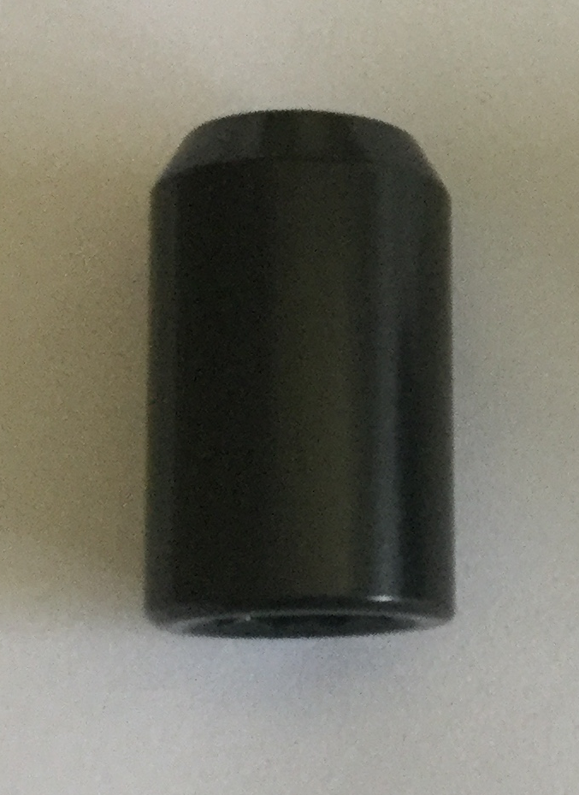
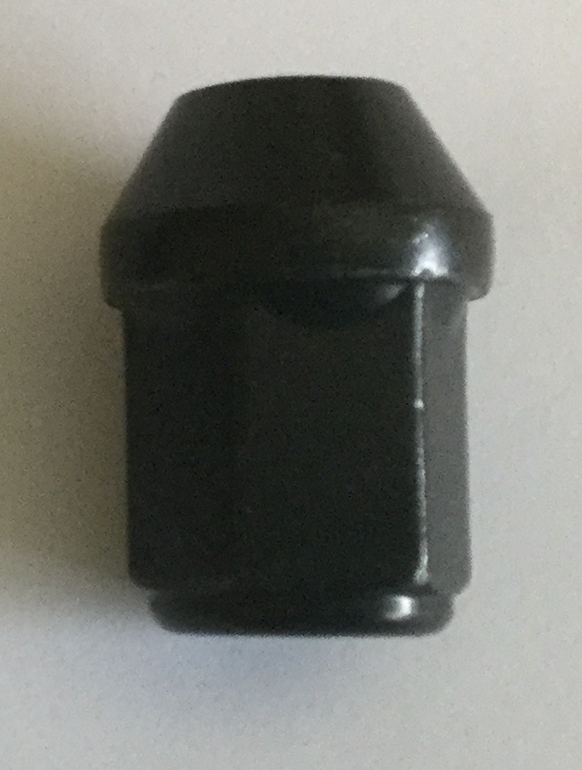

Black closed end bulge nut Black tuner nut
Closed end
PART NUMBER THREAD HEX FINISH
DN1B/B ½ unf 19 chrome
DN1B/BZ ½ unf 19 zinc
DN3B/B 12 x 1.25 19 zinc
DN10B/B 12 x 1.5 19 chrome
DN10B/BZ 12 x 1.5 19 zinc
DN14B/B 14 x 1.5 19 zinc

Open end
DN3BT/B 12 x 1.25 19 zinc
DN10BT/B 12 x 1.5 19 zinc
DN14BT/B 14 x 1.5 19 zinc
DN15BT/B 14 x 2 19 zinc

Tuner
DN3AK/B 12 x 1.25 Hexagon chrome
DN3SK/B 12 x 1.25 Spline chrome
DN10SK/B 12 x 1.5 Spline chrome

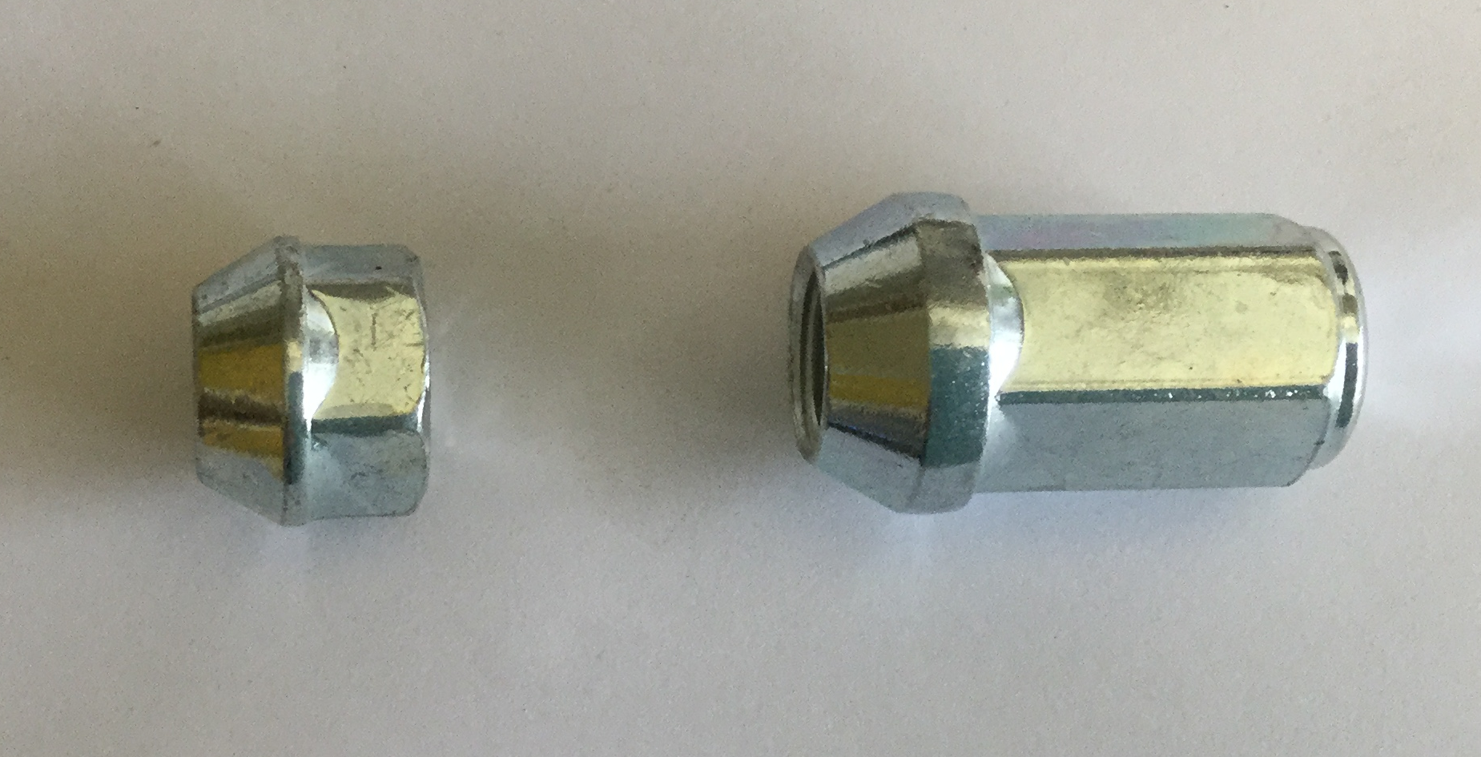

Short open end nut Extended closed nut
Short nuts

PART NUMBER THREAD HEX FINISH

DN14RS (radius) 14x1.5 19 zinc (stainless cap)

Short headed nuts

DN1BTS ½ unf 19 zinc
DN3BTS 12 x 1.25 19 zinc
DN10BTS 12 x 1.5 19 zinc
DN14BTS 14 x 1.5 19 zinc

Long nuts
DN10LONG 12 x 1.5 19 chrome
DN14BL 14 x 1.5 19 zinc
DN3LN 12 x 1.25 19 zinc
(long nose)
DN10LN 12 x 1.5 19 zinc
(long nose)

Variable PCD nuts
When fitting, 8 full turns are needed

VN1 12x1.5 19 zinc
VN1/17 12x1.5 17 chrome
VN2 12x1.25 19 zinc
VN2/17 12x1.25 17 chrome
VN3 ½ unf 17 zinc

Tuner nuts
(20mm diameter)
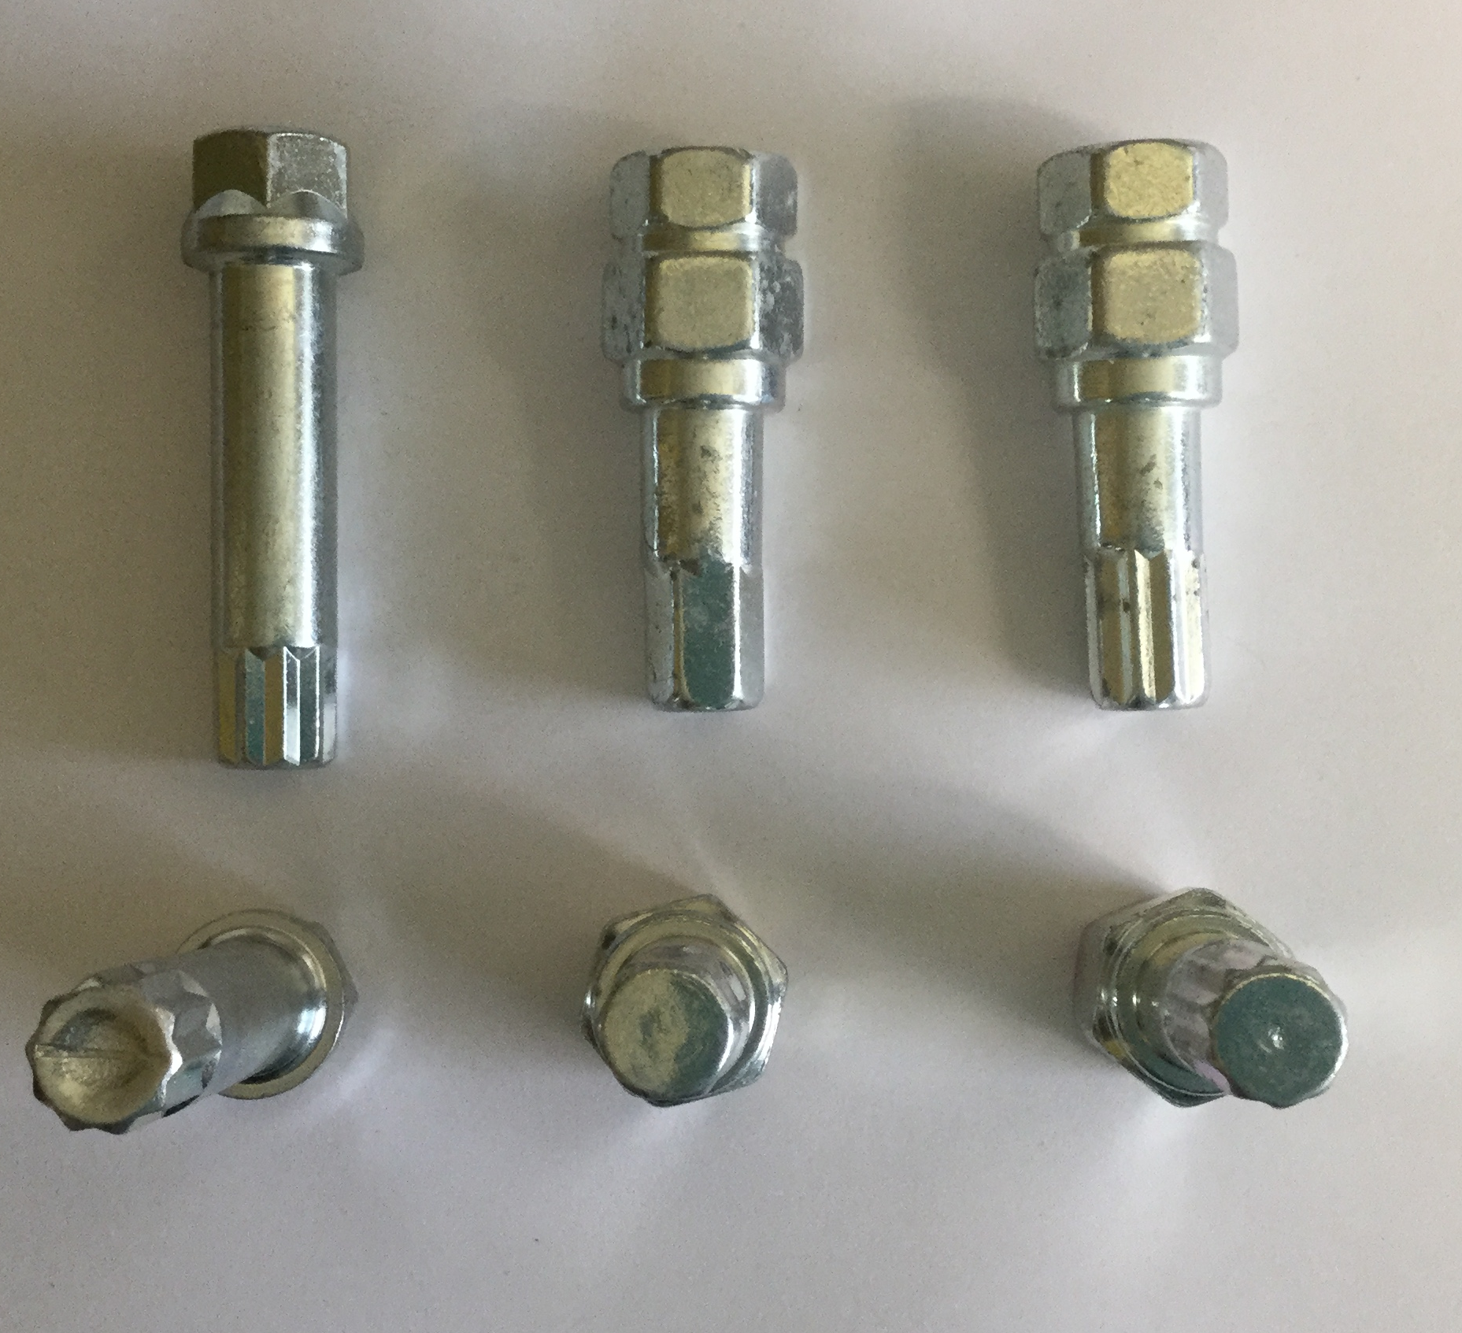
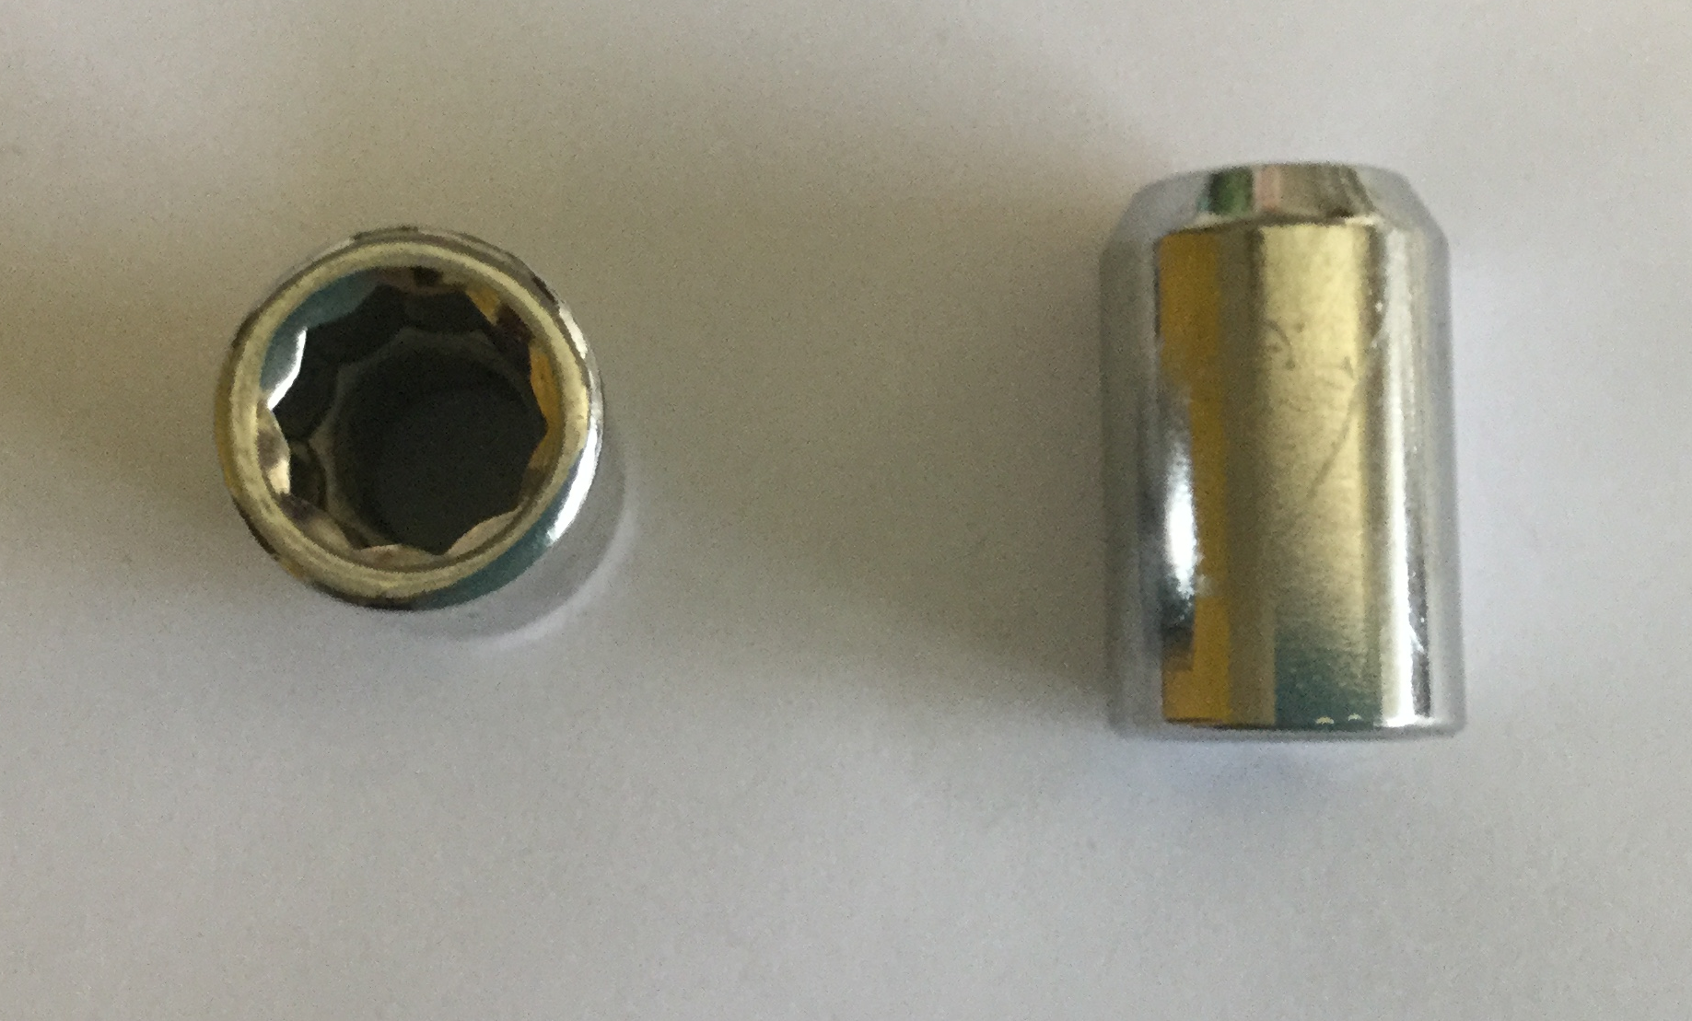

Tuner nut SK AK SK19
PART NUMBER THREAD KEY TYPE FINISH
DN1SK ½ unf spline zinc
DN2AK 7/16 unf hexagon chrome
DN3AK 12x1.25 hexagon chrome
DN3SK 12x1.25 spline chrome
DN3SKZ 12x1.25 spline zinc
DN5AK 3/8 unf hexagon chrome
DN10AK 12x1.5 hexagon chrome
DN10SK 12x1.5 spline chrome
DN10SKZ 12x1.5 spline zinc
DN14SK 14x1.5 spline zinc
DN15SK 14x2 spline zinc (23mm diameter)

DN10TK 12x1.5 chrome – Closed-end tuner nut with external spline
Tuner Keys
PART NUMBER STYLE HEX FINISH
AK hexagon 19/21 zinc
SK 10 point spline 17 zinc
SK19 10 point spline 19/21 zinc
SKL (116mm long) 10 point spline 17 zinc
TK external spline 19/21 black

Flat seat nuts

PART NUMBEER THREAD SEATING
PEB/N 12x1.25 flat

Sleeve nut
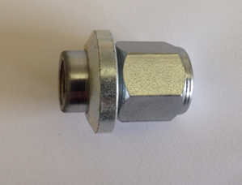

Wolfrace style - (11/16 – large bore, 41/64 - small bore)
Part number Thread Shank Diameter
01 ½ unf 11/16
02 7/16unf 11/16
03 7/16 unf 41/64
04 3/8 unf 41/64
05 12 x 1.5 41/64
06 12 x 1.5 11/16
07 12 x 1.25 41/64
08 12 x 1.25 11/16
09 1/2unf 11/16
(scimitar only )
012 14 x 1.5 11/16
020 16 x 1.5 20mm
(range rover only) (27mm hex)

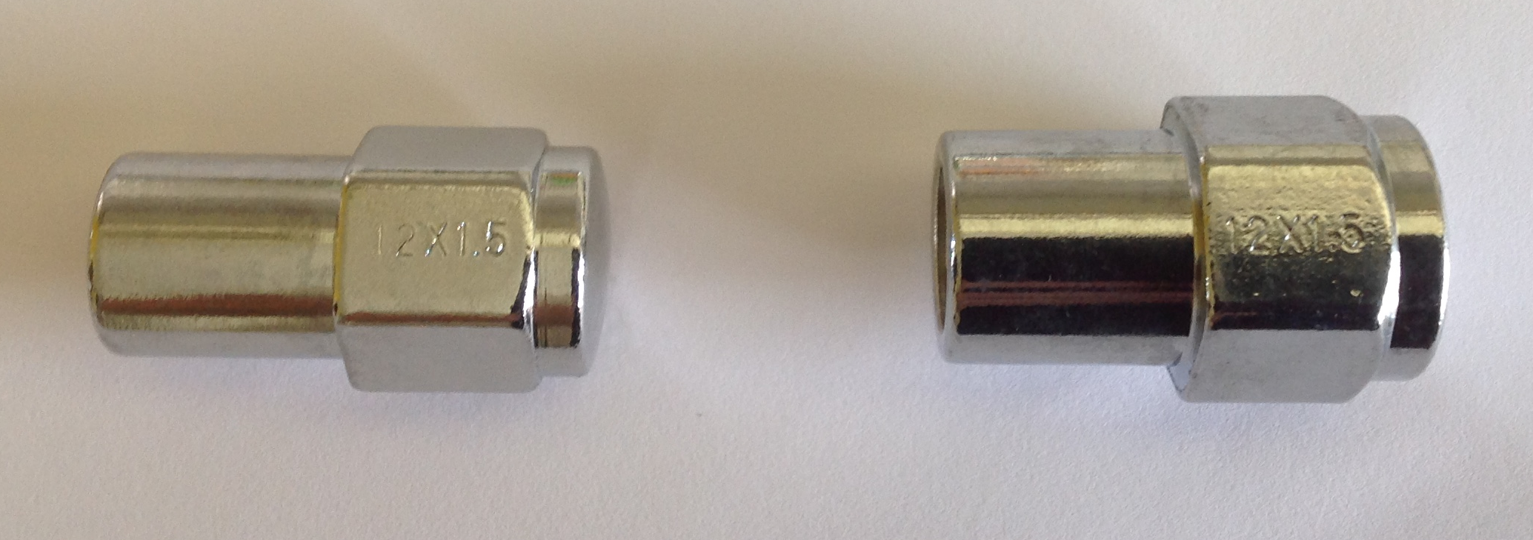

Cobra style - (5/8 - small bore, 3/4 - large bore)
Part number Thread Shank Diameter
SN10GG 12 x 1.5 5/8
SN10G 12 x 1.5 3/4
SN2B 7/16 unf 5/8
SN2AB 7/16 unf 3/4
SN3FF 12 x 1.25 5/8
SN3F 12 X 1.25 3/4
SN6A 3/8 unf 5/8
SN1E 1/2 unf 3/4
SN14 14 x 1.5 3/4

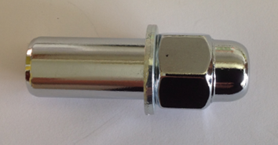

Revolution style
Part number Thread Shank Diameter Shank length
Rev1 ½ unf 11/16 35mm
Rev2 7/16 unf 11/16 35mm
Rev10 12x1.5 11/16 35mm
Revbk 3/8 unf 11/16 35mm
Rev6 3/8unf 9/16 35mm

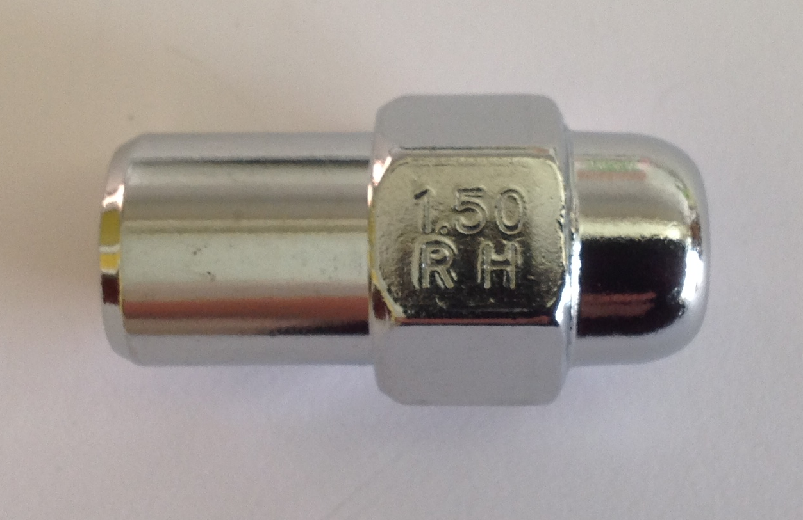

US Mag nut
Part number Thread Shank Diameter Shank length
SNUSM1 1/2unf 11/16 20mm
SNUSM2 7/16 unf 11/16 20mm
SNUSM10 12 x 1.5 11/16 20mm

Nut Covers
Part number Hexagon Finish
Covers/17/B 17mm Black
Covers/17/C 17mm Chrome
Covers/19/B 19mm Black
Covers/19/C 19mm Chrome
Covers/21/B 21mm Black
Covers/21/C 21mm Chrome

Original equipment style nuts
Part number Thread Manufacturer Seating
10F 12 x 1.5 Ford ghia tapered washer
10FO/END 12 x 1.5 Ford ghia tapered washer
(open end)
12F 12 x 1.5 Ford large taper
(new style)
14F 14 x 1.5 Ford large taper
(new style) (21mm hex)
15F 14 x 2 Ford transit flat washer
16F 14 x 1.5 Ford transit flat washer
101 ½ unf Jaguar flat washer
102 3/8 unf Mini/Metro 60 ° taper washer
103 12 x 1.5 MG/Rover 60 ° taper washer
104 16 x 1.5 Range Rover until 93, flat washer
Defender 90-110 & Discover 93-38,
104/14 14 x 1.5 Range Rover 93-02 flat washer
Discovery 98-04
105 12x1.5 Honda radius
107 3/8 unf Pepperpot nut
108 12 x 1.5 Freelander radius
(Black 21mm hex)
109 14 x 1.5 Range rover flat washer
(2002-2005 only)
110 14 x 1.5 Range Rover 06 on, flat washer
Range Rover Sport & Discovery 04 on
110/B 14 x 1.5 Range Rover 06 on, flat washer
(Black finish) Range Rover Sport & Discovery 04 on
110/C 14 x 1.5 Range Rover 06 on, flat washer
(chrome) Range Rover Sport & Discovery 04 on
111 12 x 1.5 Jaguar flat washer
SNTOY 12 x 1.5 Toyota/Mitsubishi flat seating sleeve nut

Washers and collars
Part number Hole diameter Seating
10FW/B 12mm ford ghia fitment
12E/COL 12mm taper
WL 19mm (3/4) flat to flat
WLT (thin) 19mm (3/4) flat to flat
WM 9/16 flat to flat
(for rev6 nut)
WR 11/16 flat to flat
WS 5/8 flat to flat
WST (thick) 5/8 flat to flat
WT12MMT (thick) 12mm taper
WT14MM 14mm taper
WTR 14mm taper to radius
WTR/12 12mm taper to radius
WW1 (wolfrace) 41/64 taper to taper
WW2 (wolfrace) 11/16 taper to taper
WW6 (wolfrace) 11/16 taper to taper
(for 09 nut only)
WW7 (wolfrace) 20mm taper to taper
(for 020 nut only)

Collars
W/110 - Range rover to T5 conversion collar
W/PEB - Taper to flat seat Peugeot washer
W/PEB - Taper to flat seat Peugeot washer

Standard steel inserts
IS/1 - 19mm spline
IS/2 - 25mm spline

Tyre valves
TV1 - chrome
Budget lock bolts
PART NUMBER THREAD SEATING LENGTH
B14 14x1.5 taper 28mm
B14R 14x1.5 radius 27mm
B14R/R14 14x1.5 radius 32mm (R14)
B14TK 14x1.5 tuner 25mm
B14V 14.1.5 vari 28mm
B15 12x1.5 radius 25mm
B16 16x1.5 taper 33mm
B17 12x1.5 taper 25mm
B17TK 12x1.5 tuner 25mm
B22 12x1.25 taper 28mm
B22TK 12x1.25 tuner 25mm
B25/14T 14x1.5 taper 25mm
B25/25T 12x1.25 taper 25mm
B40/14R 14x1.5 radius 40mm
B425 14x1.25 taper 28mm
B425TK 14x1.25 tuner 25mm

Black budget lock bolts

B14/B 14x1.5 taper 28mm
B14TK/B 14x1.5 tuner 28mm
B14R/B 14x1.5 radius 27mm
B17/B 12x1.5 taper 25mm
B425/B 14x1.25 taper 28mm

Mid range lock bolts
PART NUMBER THREAD SEATING LENGTH
B30/14T 15x1.25 taper 30mm
B33/5T 12x1.5 taper 33mm
B35/14R 14x1.5 radius 35mm
B35/14T 14x1.5 taper 35mm
B40/14R 14x1.5 radius 40mm
B40/14T 14x1.5 taper 40mm
B40/25T 12x1.25 taper 40mm
B40R 12x1.5 radius 40mm
B40T 12x1.5 taper 40mm
B43/425T 14x1.25 taper 43mm
B45/14T 14x1.5 taper 45mm
B45/14R 14x1.5 radius 45mm
B45/5T 12x1.5 taper 45mm
B50/14T 14x1.5 taper 50mm
B50/14R 14x1.5 radius 50mm
B50/25T 12x1.25 taper 50mm
B50/425T 14x1.25 taper 50mm
B60T 12x1.5 taper 60mm

Mid range lock bolts black
B35/14R/B 14x1.5 radius 35mm
B35/14T/B 14x1.5 taper 35mm
B40/14T/1B 14x1.5 taper 40mm
B40/T/B 12x1.5 taper 40mm
B40/14R/B 14x1.5 radius 40mm
B40/425T/B 14x1.25 radius 40mm
B43/425T/B 14x1.25 radius 43mm
B45/14T/B 14x1.5 taper 45mm
B45/14R/B 14x1.5 radius 45mm
B50/425T/B 14x1.25 taper 50mm
B45/5T/B 12x1.5 taper 45mm
B50/14T/B 14x1.5 taper 50mm
B50/425T/B 14x1.25 taper 50mm

Limpet lock bolts

PART NUMBER THREAD SEATING LENGTH

LBS10B 12x.1.5 ford seating 25mm
LBS13 12x1.25 taper 28mm
LBS14R 14x1.5 radius 28mm
LBS14R19 14x1.5 radius 28mm (19 hex)
LBS14T 14x1.5 taper 34mm
LBS14T19 14x1.5 taper 34mm (19hex)
LBS15 12x1.5 radius 26mm
LBS17 12x1.5 taper 26mm
LBS22 12x1.25 taper 28mm
LBS22/17 12x1.25 taper 28mm (17 hex)
LBS24/17 12x1.5 taper 27mm (17 hex)
LBS35/14R 14x1.5 radius 35mm
LBS40/14T 14x1.5 taper 40mm
LBS40/425T 14x1.25 taper 40mm
LBS40R 14x1.5 radius 40mm
LBS40T 14x1.5 taper 40mm
LBS425 14x1.25 taper 27mm
LBS50/14T 14x1.5 taper 50mm
LBS50/14R 14x1.5 radius 50mm
LBS50/25T17 12x1.25 taper 50mm (17 hex)
LBS50/25T 12x1.25 taper 50mm
LBS50/5R 12x1.5 radius 50mm
LBS50/5T 12x1.5 radius 50mm
LBS50/425T 14x1.25 taper 50mm
LBSPEB1 12x1.5 flat 31mm
LBSPEB2 12x1.25 flat 35mm (19 hex)
LBSPEB3 12x1.25 flat 35mm (19 hex)
LBSPEB4 12x1.25 flat 35mm (17 hex)
LBSWB1 12x.1.5 vari 32mm
LBSWB2 12x.1.25 vari 32mm
LBSWB3 14x.1.5 vari 32mm

Budget lock nuts
All budget lock nuts come in taper seating
Part number Thread End
N1 ½” closed
N1TK ½” tuner
N10 12x1.5 closed
N10/OE 12x1.5 open
N10/TK 12x1.5 tuner
N14 14x1.5 closed
N14L 14x1.5 closed (40mm)
N14/OE 14x1.5 open
N14/TK 14x1.5 tuner
N3 12x1.25 closed
N3/OE 12x1.25 open
N3TK 12x1.25 tuner
N5/SC 3/8unf open
(with stainless steel cap)
N15 14x2 closed

Black budget lock nuts
N3/B 12x1.25 closed
N10/B 12x1.5 closed
N14/B 14x1.5 closed

Limpet lock nuts
PART NUMBER HEX THREAD END SEATING
LNL/R/4 27 16x1.5 closed taper (steel wheels)
LNL/R/5 27 16x1.5 closed taper (5 nut set)
LNS1 19 ½” closed taper
LNS1/21 21 ½” closed taper
LNS3 19 12x1.25 closed taper
LNS10 19 12x1.5 closed taper
LNS10/17 17 12x1.5 closed taper
LNS10/21 21 12x1.5 closed taper
LNS102 3/8 unf closed taper (loose washer)
LNS103 19 12x1.5 closed taper (loose washer)
LNS103J 19 12x1.5 closed flat (jaguar OE)
LNS104/4 27 16x1. 5 closed flat sleeve (set of 4)
LNS104/5 27 16x1.5 closed flat sleeve (set of 5)
LNS104/14 27 14x1.5 closed flat sleeve
LNS104/145 27 14x1.5 closed flat sleeve (set of 5)
LNS108 22 12x1.5 closed radius (freelander)
LNS108/5 22 12x1.5 closed radius (set of 5)
LNS109 22 14x1.5 closed flat sleeve
(range rover 05 on)
LNS10F/G 19 12x1.5 closed taper with loose washer (ghia)
LNS10F/OE 19 12x1.5 open taper with loose washer (ghia)
LNS10R 19 12x1.5 closed radius
LNS10T 21 12x1.5 closed flat sleeve (toy/mits)
LNS110 . 14x1.5 closed flat sleeve (rr sport)
LNS14 19 14x1.5 closed taper
LNS15 19 14x2 closed taper
LNS2 19 7/16unf closed taper
LNS3/21 21 12x1.25 closed taper
LNS5 17 3/8unf closed taper
LNS6 17 3/8unf closed radius
LNSVN1 19 12x1.5 closed taper (variable PCD)

Studs
Part number thread length spline diameter
(mm) (mm)
Mini, Morris Minor, Sprite, Metro Mk1
SS3/81 3/8 unf 35 10.3
SS3/82 3/8 unf 50 10.3
SS3/83 3/8 unf 60 10.3
SS3/84 3/8 unf 80 10.3

Ford
SS7/16S 7/16 unf 43 13.1
SS7/16L 7/16 unf 55 13.1
SS12/S 12x1.5 47 13.1
SS12/L 12x1.5 63 13.1

Honda
SS12H 12 x 1.5 62 12.4
Subaru, Nissan
SS25 12x1.25 63 14.3

Vauxhall, Opel, Mitsubishi, Toyota
SSVO/S 12x1.5 51 14.3
SSVO 12x1.5 63 14.3
Volkswagen
SS14 14x1.5 60 15.0
SS14/L 14x1.5 70 15.0
Volvo
SSVV 12x1.5 67 16.5

We also have a range of classic, triumph and MG studs and nuts available; please contact our sales department for further information.

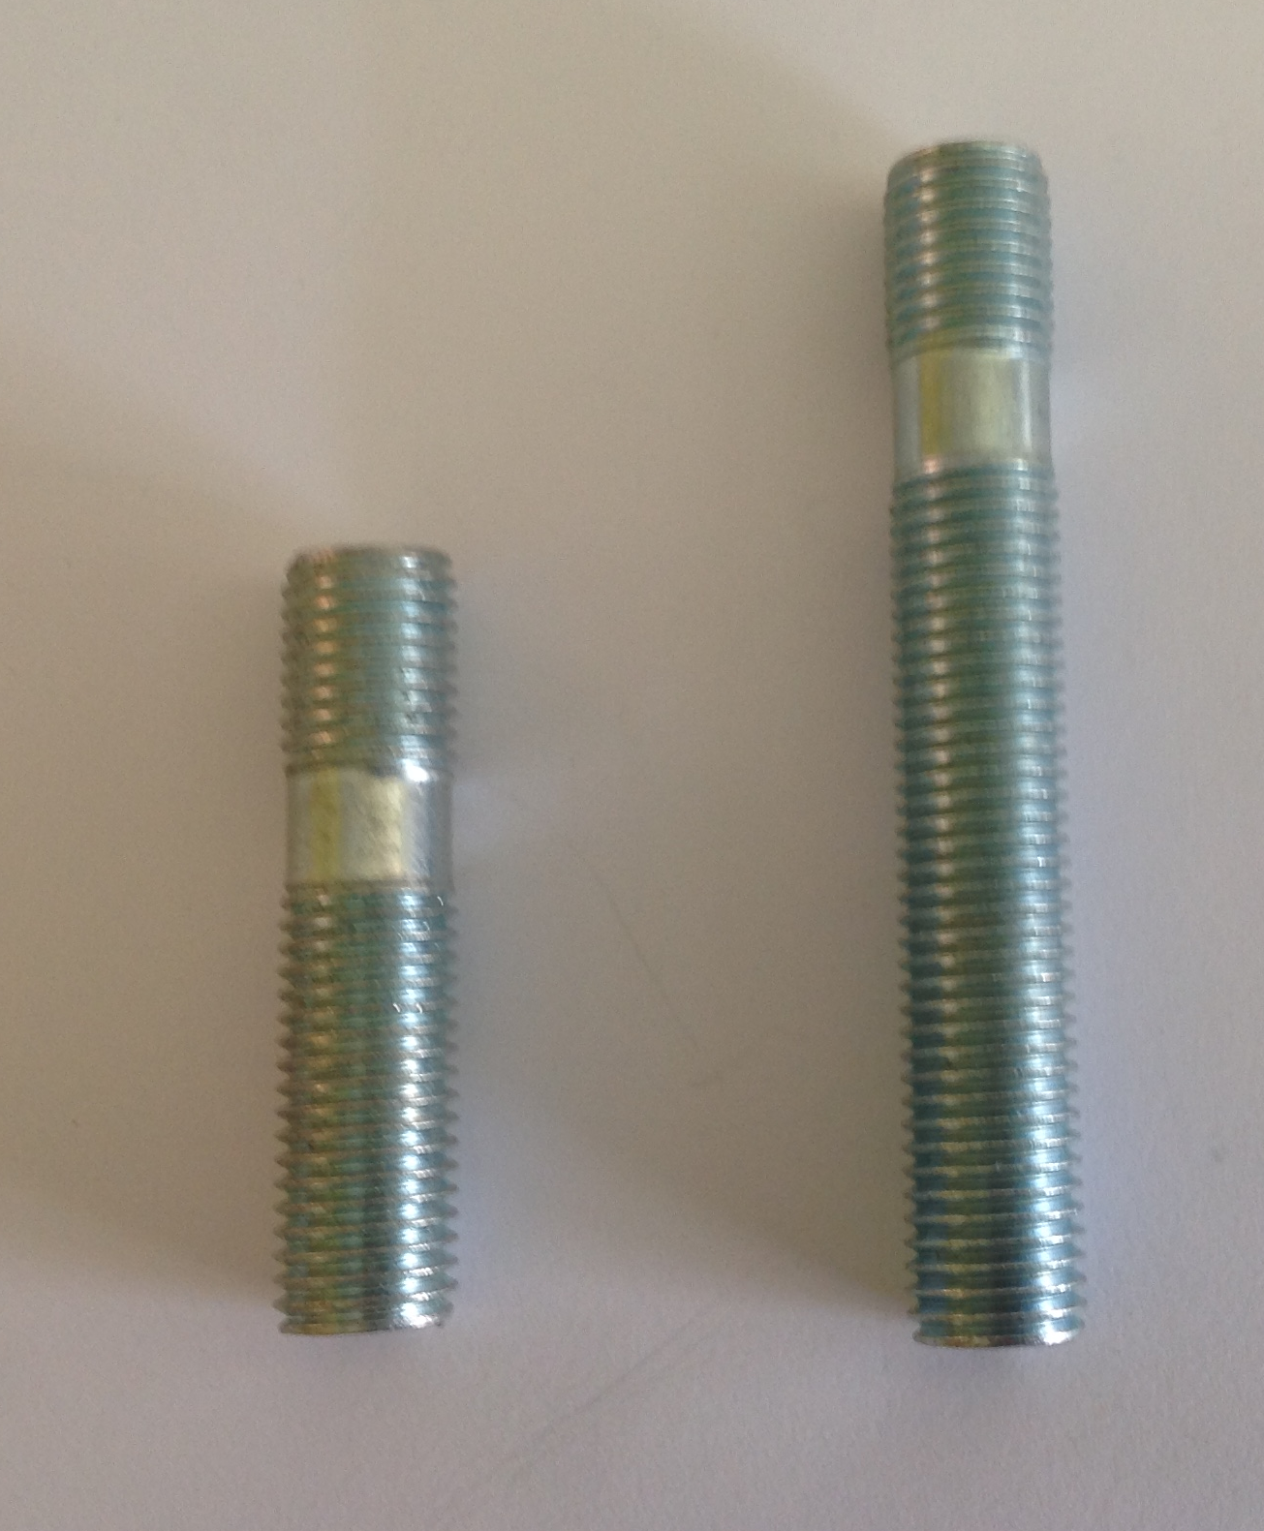
Conversion studs

PART NUMBER THREAD LENGTH (MM)
CSS1 12x1.5 50
CSS2 12x1.5 60
CSS3 12x1.25 45
CSS4 12x1.25 50
CSS5 12x1.25 60
CSS6 12x1.25 40
CSS7 14x1.5 40
CSS8 14x1.5 50
CSS9 14x1.5 60
CSS11 12x1.5 40
CSS12 12x1.25 80
CSS13 14x1.5 80
CSS14 12x1.5 80
CSS15 12x1.25 100

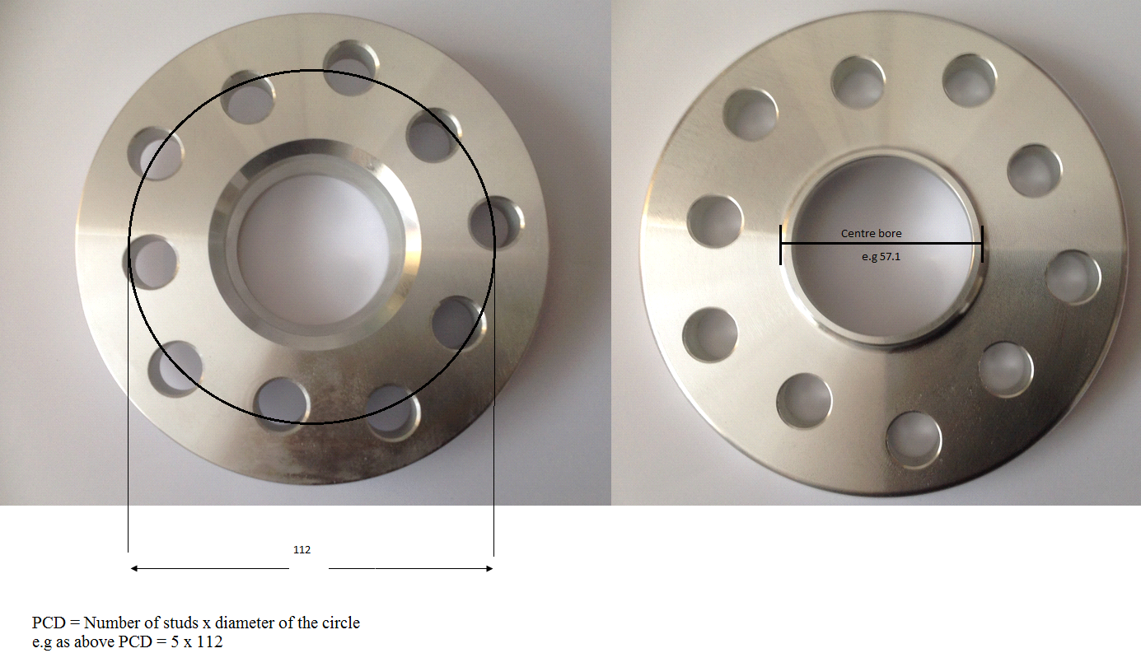
Hubcentric spacers (billet aluminium)
PART NUMBER PCD CENTRE BORE THICKNESS
HSB13 5x120 72.6 13mm
HSB15 5x120 72.6 15mm
HSB16/741 5x120 74.1 16mm
HSB20 5x120 72.6 20mm
HSB741/726/15 5x120 74.1-72.6 15mm
HSB20/741 5x120 74.1 20mm
HSB20/741/726 5x120 74.1 -72.6 20mm
HSB25 5x120 72.6 25mm
HSF16 4x108 63.4 16mm
HSF20 4x108 63.4 20mm
HSF516 5x108 63.4 16mm
HSFI16 4x98 58.1 16mm
HSH16 4x100 56.1 16mm
HSM10 5x112 66.6 10mm
HSM15 5x112 66.6 15mm
HSM20 5x112 66.6 20mm
HSM25 5x112 66.6 25mm
PART NUMBER PCD CENTRE BORE THICKNESS
HSN16 5x114.3 66.1 16mm
HSP10 4x108 65.1 10mm
HSP15 4x108 65.1 15mm
HSP20 4x108 65.1 20mm
HSP516 5x108 65.1 16mm
HSPO16 5x130 71.6 16mm
HSPO20 5x130 71.6 20mm
HSR16 4x100 60.1 16mm
HSR20 4x100 60.1 20mm
HSR20/5 5x108 60.1 20mm
HSS16 5x100 56.1 16mm
HSS20 5x100 56.1 20mm
HST20 5x114.3 60.1 20mm
HSV16 5x110 65.1 16mm
HSV16/4 4x100 56.6 16mm
HSV20 5x110 65.1 20mm
HSVW15 5x112 57.1 15mm
HSVW15/4 4x100 57.1 15mm
HSVW20 5x112 57.1 20mm
HSVW15 5x112 57.1 15mm
HSVW20/4 4x100 57.1 20mm
HSVW25 5x112 57.1 25mm
HSVWT15 5x120 65.1 15mm
HSVWT20 5x120 65.1 20mm

Hubcentric Spacers – Available in Black

PART NUMBER PCD CENTRE BORE THICKNESS
HSB15B 5x120 72.6 15mm
HSB20B 5x120 72.6 20mm
HSM15B 5x112 66.6 15mm
HSM20B 5x112 66.6 20mm
HSVW15B 5x112 57.1 15mm
HSVW20B 5x112 57.1 20mm
HSVWT10 5x120 65.1 10mm

Universal spacers
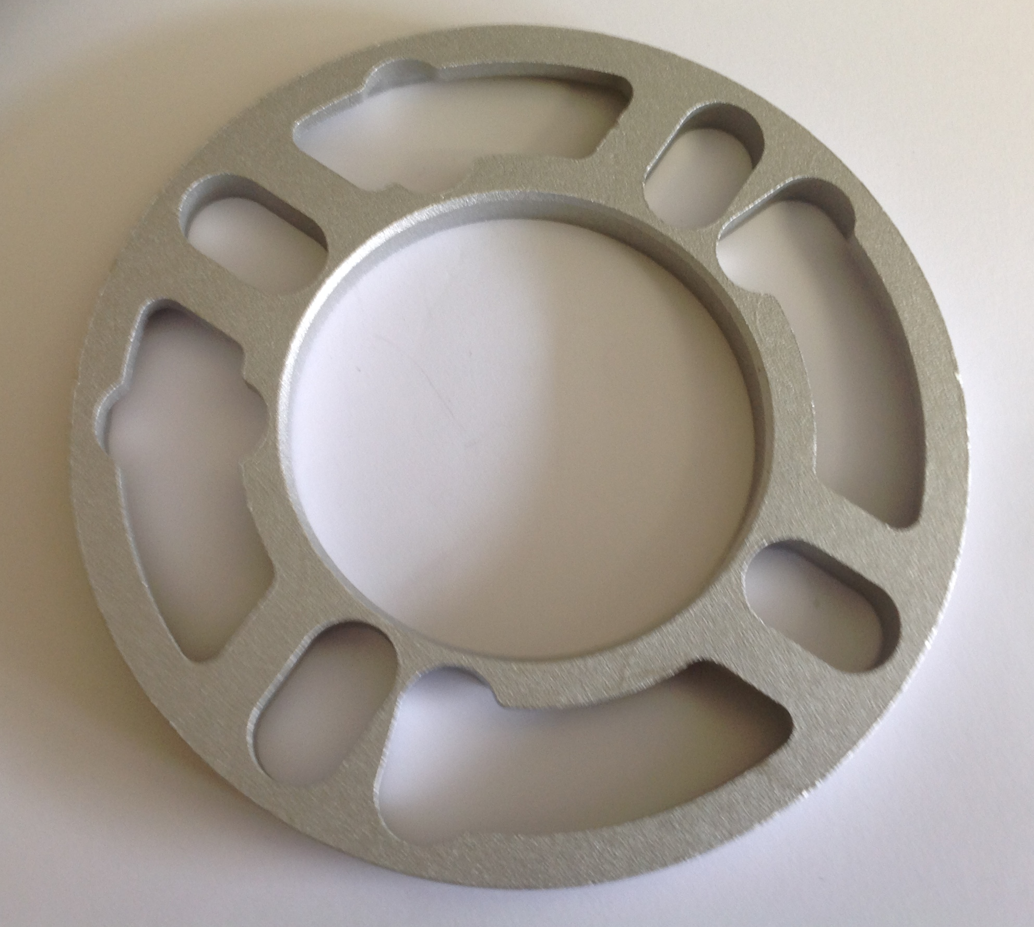
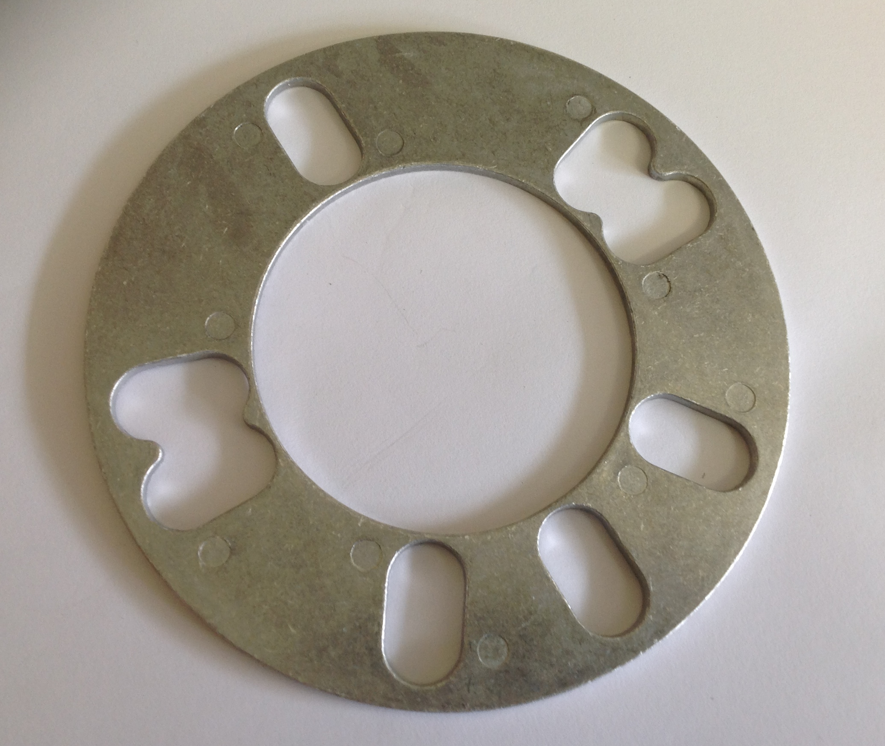

All universal spacers are made of die cast aluminium

PART NUMBER HOLES THICKNESS PCD
SH3M/3 3 3mm 98mm
SH3M 4-5 3mm 95-121mm
SH5M 4-5 5mm 95-121mm
SH5M/6 5-6 5mm 139.7
SH6M/6 5-6 6mm 139.7
SH8M 4-5 8mm 95-121mm
SH9M 5 10mm 95-130mm
SH10M 4-5 10mm 95-121mm
SH10M/6 5-6 10mm 139.7
SP3/8 4 3/8” 95-114mm
SP3/4 4 3/4" 95-114mm
SP20M 5 20mm 95-130mm
SP1 4 1” 95-114mm

Spigot Rings
Other sizes are available on request, please call for further information.
PART NUMBER OUTER SIZE INNER SIZE
SR601561 60.1 56.1
SR601566 60.1 56.6
SR60541 60.1 54.1
SR601571 60.1 57.1

SR634541 63.4 54.1
SR634561 63.4 56.1
SR634571 63.4 57.1
SR634601 63.4 60.1

SR651634 65.1 63.4
SR666571 66.6 57.1
SR666651 66.6 65.1

SR671541 67.1 54.1
SR671561 67.1 56.1
SR671566 67.1 56.6
SR671571 67.1 57.1
SR671581 67.1 58.1
SR671601 67.1 60.1
SR671634 67.1 63.4
SR671641 67.1 64.1
SR671651 67.1 65.1
SR671661 67.1 66.1

SR701561 70.1 56.1
SR701566 70.1 56.6
SR701571 70.1 57.1
SR701601 70.1 60.1
SR701634 70.1 63.4
SR701651 70.1 65.1
SR701661 70.1 66.1
SR701666 70.1 66.6
SR701671 70.1 67.1

PART NUMBER OUTER SIZE INNER SIZE

SR72571 72.1 57.1
SR72591 72.1 59.1

SR726541 72.6 54.1
SR726561 72.6 56.1
SR726566 72.6 56.6
SR726571 72.6 57.1
SR726581 72.6 58.1
SR726601 72.6 60.1
SR726634 72.6 63.4
SR726641 72.6 64.1
SR726651 72.6 65.1
SR726661 72.6 66.1
SR726666 72.6 66.6
SR726671 72.6 67.1
SR726701 72.6 70.1
SR726711 72.6 71.1

SR73541 73.1 54.1
SR73561 73.1 56.1
SR73566 73.1 56.6
SR73571 73.1 57.1
SR73581 73.1 58.1
SR73591 73.1 59.1
SR73596 73.1 59.6
SR73601 73.1 60.1
SR73634 73.1 63.4
SR73641 73.1 64.1
SR73651 73.1 65.1
SR73661 73.1 66.1
SR73665 73.1 66.5
SR73671 73.1 67.1
SR73703 73.1 70.3
SR73716 73.1 71.6

SR741571 74.1 57.1
SR741651 74.1 65.1
SR741711 74.1 71.1
SR741726 74.1 72.6

Other products available upon enquiry include:
- Classic, triumph MG studs and nuts
- Variety of other spigot ring sizes

About the company
Select Auto Supplies Ltd is a family owned and run business that has been trading since 1982. All of the information supplied in this catalogue has been compiled with care, however due to vehicle modifications and changes it is important that customers take care to check the specifics of the vehicle before fitting any of the products. Although all care is taken, products may vary slightly from images.
If you have any queries please feel free to contact our technical department.

